**Project Description:**

The project I initially proposed was to characterize factors conferring antibiotic resistance in *Pseudomonas stutzeri*, also referred to as 57B2. In *P. aeruginosa,* a strain genetically similar to *P. stutzeri*, the*mexAB-oprM* operon encodes for an efflux pump that is responsible for resistance to multiple antimicrobials; this resistance is often the result of mutations in a proximal regulator downstream of the operon. Recently, we identified a MexAB-OprM homolog in *P. stutzeri*with the highest identity to MexAB-OprM that did not contain a proximal regulator. My project was to characterize whether this efflux pump is constitutively expressed using reverse-transcription PCR (RT-PCR) and using gene deletion to test whether it effluxes known substrates of *P. aeruginosa* MexAB-OprM. However, after first confirming the expression of this homologous gene in *P. stutzeri*, I was unable to complete Gibson assembly and SacB-mediated sucrose counter-selection to delete the gene segment as I had originally planned because the primers for Gibson assembly need to be redesigned. Instead, I am attempting to express a gene thought to contribute to triclosan resistance in *P. stutzeri* to determine the function of the gene of interest.

**Project Progress:**

Earlier in the summer, the gene 01397 was discovered in *P. stutzeri*. 01397 is a distant homolog of fabI, which functions as an enoyl acyl reductase in *P. aeruginosa* and contributes to triclosan resistance in this strain. If the gene of interest, 01397, is found to confer antibiotic resistance in *P. stutzeri*, then certain strains of *Pseudomonas* have more than one types of fabI gene influencing triclosan resistance. Currently, I am attempting to express this gene in *E. coli*SM10 by first extracting the plasmid vector puc-IDT-03197 from transformed *E. coli*SM10, amplifying 01397 via PCR with primers that create specific homology arms, and purifying the PCR product. Next, I transformed SM10 with a plasmid vector known as pBAD-24 which contains an ampicillin resistance gene. I then extracted pBAD-24 and linearized the plasmid with EcoRI to create overhangs that match the 01397 homology arms. The linearized pBAD-24 plasmid and 01397 insert were joined using Gibson assembly and the resulting plasmid vector-insertion combination was transformed into SM10 for expression. Transformed cells were grown in the presence of ampicillin in order to select for colonies that took up the pBAD-24-01397 Gibson product. Finally, I conducted colony PCR on transformed colonies to test for the presence of, and amplify, the 01397 gene.

**Project Results:**

The concentration of 01397 DNA after the PCR purification was 71.293 ng/ul while the concentration of linearized pBAD-24 was 132.802 ng/ul. Using these concentrations, 50 ng of the pBAD-24 vector and 100 ng of the 01397 insert were used for Gibson assembly and transformed into *E. coli* SM10 in the presence of ampicillin and a control plate. The TSA control plate yielded a lawn while the TSA+AMP plate yielded only 5 distinct colonies. These 5 colonies were used for colony PCR to determine if 01397 was present in the transformed colonies. Additionally, I used the empty pBAD-24 vector and the puc-IDT-01397 insert as a negative and positive control, respectively. The PCR was conducted twice, with two different primer sets; one set acted as a negative control (primer set 55 and 56) while the other was the positive control (primer set 59 and 60). See figure 1 on page 3 to visualize the results. Four out of the five colonies tested were positive for containing the 01397 insert when amplified with primers 059 and 060 as these four colonies had band lengths of 383 bp. These colonies did not produce a band of this length when amplified with primers 055 and 056. The positive control, pUDICT-01397, yielded a band of the expected length of 383 bp with primers 059 and 060 however did not yield the expected result of <500 bp for primers 055 and 056 for unknown reasons. Finally, the negative control, the empty vector pBAD-24, yielded a band of 383 bp when amplified with primers 059 and 060. This is also an unexpected result as the empty vector should not have the 01397 insert that these primers amplify. In order to further investigate as to why this occurred, I will be repeating this experiment with *E. coli* JP1111 instead of *E. coli*SM10 to try and obtain more conclusive results. This will also allow me to retest my positive and negative controls for contamination.

**Academic Development:**

During my completion of this project, I have gained many important skills and experiences that have contributed positively to my academic development. Specifically, I would say that learning the importance of consistent and organized data entry. Prior to this project, my lab notebook was unorganized and it was always difficult for me to synthesis my data in order to analysis results and come to conclusions. However, I feel that this summer I have development important data entry, synthesis, and analysis skills. I have also honed the skills and techniques that I used daily in the lab in order to become a more efficient researcher. Most importantly, however, I have learned how to deal with setbacks in the lab and adjusting my planned research goals when they occur rather than resigning in frustration when faced with these challenges.

**Personal Development:**

During this grant period, I was able to grow in order to become a more independent person, student, and researcher. The increased autonomy I had during my time in the lab allowed me to exercise independent problem solving and critical thinking skills that are essential when conducting research. This type of growth that I experienced in the lab this summer has reinforced my desire to continue on the path I am on as I enjoy the challenges that come with scientific research and enjoy improving and practicing the skills needed to overcome such challenges; realizing this was an important step in continuing my education as I am now confident in my decision to continue to pursue a research based career.

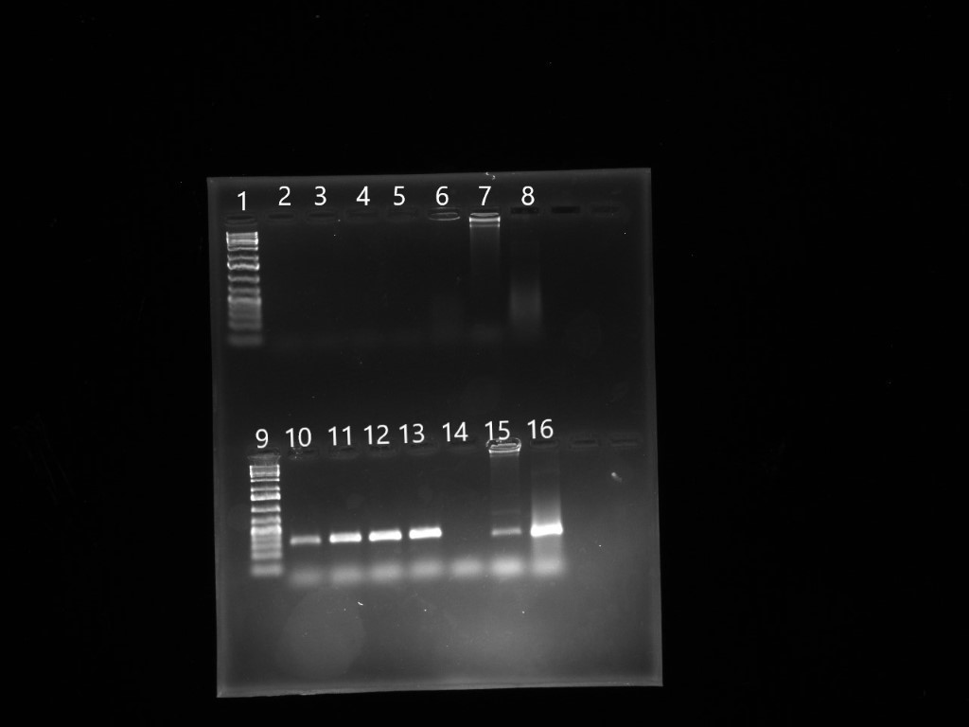Figure 1: PCR to amplify 01397 gene in transformed SM10 cells

1: 1kb genruler plus ladder; 2: transformed colony 3.1, primers 055/056; 3: transformed colony 3.2, primers 055/056; 4: transformed colony 3.3, primers 055/056; 5: transformed colony 3.4, primers 055/056; 6: transformed colony 3.5, primers 055/056; 7: pBAD-24, primers 055/056; 8: puc-IDT-01397, primers 055/056; 9: 1 kb genruler plus ladder; 10: transformed colony 3.1, primers 059/060; 11: transformed colony 3.2, primers 059/060; 12: transformed colony 3.3, primers 059/060; 13: transformed colony 3.4, primers 059/060; 14: transformed colony 3.5, primers 059/060; 15: pBAD-24, primers 059/060; 16: puc-IDT-01397, primers 059/060.